EDITORIAL NOTE (remove before submission): This chapter reports the student's own real, already-completed AMIRIS experimental work (documented in AMIRIS_Germany2027_Progress_Report.pdf). The prose was drafted by Claude (Anthropic) per the student's explicit authorization, from the project's own verified results and commentary -- no external literature synthesis is involved here, so this chapter falls under the AI-usage policy's 'create texts / data analysis, citation of prompt necessary' category rather than the barred 'summarise state of research' category. Prompt citation: Claude Sonnet 5 (Anthropic), output generated 18 September 2026, session https://claude.ai/code/session_01VmiP7rpUwBmA2YjSGWGxHo. All figures below are taken directly from generate_2027_progress_report.py / AMIRIS_Germany2027_Progress_Report.pdf; none were invented for this draft. The student should review every figure against the source report before submission.

Chapter 4: Investigating Zonal Disaggregation

4.1 Motivation: does modelling real named neighbours improve on the aggregate?
The aggregate Rest-of-Europe zone described in Section 3.3 pools nine real countries' demand, generation, and renewable output into a single simulated market. This is a coarse simplification of the real European system, in which each country clears its own day-ahead price and trades bilaterally with its actual neighbours, as Section 2.4 describes. Whether replacing this aggregate with real, individually modelled countries improves the comparison against Energy Brainpool, or whether the aggregate's built-in pooling of supply and demand across a wide area is itself doing useful work that disaggregation would undo, was tested directly rather than assumed. This chapter reports that investigation in the order it was actually carried out: a single-country pilot (Section 4.2), a full ten-zone build that exposed a genuine AMIRIS engine limitation (Section 4.3), a source-level diagnosis of why disaggregation underperformed the aggregate (Section 4.4), and a mesh-topology rebuild that tested the diagnosed mechanism directly (Section 4.5).

4.2 The France pilot
France was chosen as the first country to disaggregate from the aggregate zone: it is the single largest economy within it (407,334 GWh real 2023 demand, 146,461 MW real capacity, Eurostat) and the only country for which every required input was already independently sourced from earlier project work, save for one new figure (France's real pumped-hydro capacity, approximately 5.8 GW, RTE). A genuine three-zone build (Germany, France, and the remaining nine-country ROE aggregate) was constructed, with France's real generation fleet, dominated by 61,400 MW of nuclear capacity, given its own dedicated market and its own dedicated real transmission link to Germany (3,015/3,679 MW, derived using the same real-flow methodology as every other border in this project). One documented simplification was accepted at this stage: France trades only with Germany, not directly with the remaining nine ROE countries, a star topology revisited in Section 4.4.
Table 4.1: Headline result vs. the France disaggregation pilot.
Metric | Baseline (aggregate ROE) | France disaggregated
Shortage hours (DE) | 7 | 167
Mean price (DE) | 67.45 (Brainpool: 68.04) | 132.34
Excl-shortage bias | -2.90 | +9.65
Excl-shortage MAE | 16.69 | 19.83
Excl-shortage correlation | 0.7168 | 0.7156

The result was a clear regression on every headline metric. The cause was verified directly rather than left as a correlation: the original aggregate zone had zero shortage hours of its own, since France's very large nuclear fleet, pooled together with every other country's demand, acted as a cheap anchor keeping the whole aggregate well-supplied. Once France was pulled out, the remaining nine-country zone developed twenty real shortage hours of its own, while France's own zone became almost absurdly oversupplied in isolation (mean price 18.87 EUR/MWh, zero shortage hours) -- a real surplus, but a stranded one, reachable by Germany only through a comparatively narrow direct link rather than able to relay onward through the rest of the now-scarcer aggregate. Since Germany's transmission link with the nine-country remainder is substantially larger than its link with France alone, Germany inherits more of the remainder's new scarcity than it recovers from France's now harder-to-reach cheapness. This mechanism is a real, verified finding, though not a complete account of the full 167-hour result: Germany's own shortage-hour count exceeds what the remainder's twenty shortage hours and their overlap with Germany's can fully explain, and Germany sits at or near its transmission ceiling in only five of its own 167 shortage hours. The finding that mattered for this project's next decision, however, was already clear without fully resolving that residual: this project's star-topology simplification actively breaks the pooling effect that made the aggregate zone work well, rather than being a harmless simplification, and a fair test of full disaggregation would require real bilateral data connecting the disaggregated countries to each other, not only to Germany.

4.3 Full ten-zone disaggregation and a genuine engine limitation
The France pilot's own star-topology mechanism suggested, but did not by itself settle, how the same approach would behave once extended to all ten real neighbouring countries at once. A full eleven-zone build (Germany plus Austria, Belgium, the Czech Republic, Denmark, Norway, the Netherlands, Poland, Sweden, Switzerland, and France, each with its own real Eurostat capacity and demand, real weather-year renewable profile, and real flow-derived transmission link to Germany) was constructed to test this directly.
The first full run of this build crashed, and its cause was not obvious from the configuration, unlike every earlier issue encountered in this project's market-coupling work. Systematic bisection isolated the fault to Denmark specifically: Denmark's real total hydropower capacity (7.1 MW) is roughly three orders of magnitude smaller than every other zone's, and this specific combination of very small storage capacity within AMIRIS's multi-zone dispatch logic caused a real, reproducible engine fault. Testing confirmed the cause directly: an identical configuration with only Denmark's storage capacity values scaled upward ran cleanly every time, while the real, tiny values crashed every time; simply omitting Denmark's hydro agents did not resolve the fault either, since a different agent then failed in the same way. The working fix applied a documented, openly artificial 1,000 MW hydro-total floor to Denmark and the Netherlands (the latter flagged as being at the same risk on the same technical grounds, 37.7 MW real hydro capacity), explicitly labelled in both scenario files as a technical workaround for a genuine AMIRIS numerical limitation rather than a claim about either country's true hydropower scale.
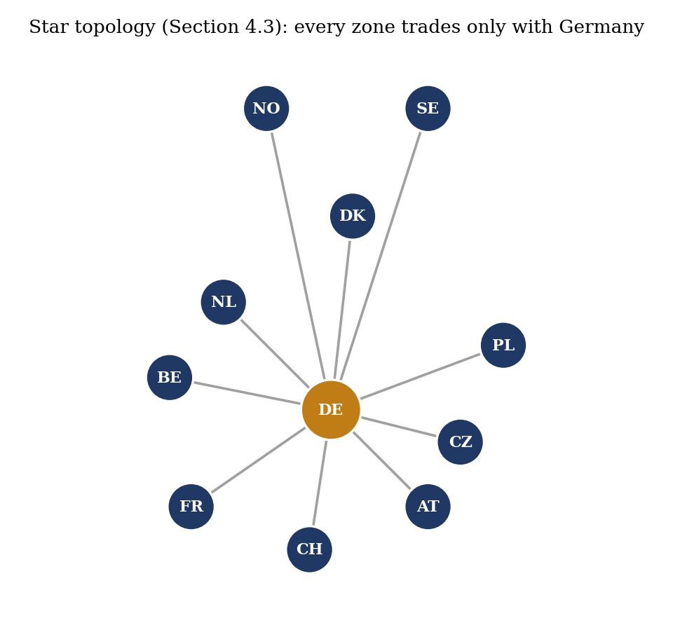
Figure 4.1: The star topology: every disaggregated zone trades only with Germany, never directly with its own real neighbours (own illustration of this project's own scenario structure).

Table 4.2: Aggregate baseline vs. France-only and full ten-zone star-topology disaggregation.
Metric | Aggregate (baseline) | France only | All ten zones (star)
Shortage hours (DE) | 7 | 167 | 120
Mean price (DE) | 67.45 | 132.34 | 112.32
Excl-shortage bias | -2.90 | +9.65 | +4.87
Excl-shortage MAE | 16.69 | 19.83 | 20.97
Excl-shortage correlation | 0.7168 | 0.7156 | 0.7311

The full-disaggregation result is more nuanced than the France pilot's own reasoning predicted. Rather than spreading the same failure mode across all ten countries and making the result worse than the single-country case, shortage hours improved relative to France-only (167 to 120), bias moved closer to zero (+9.65 to +4.87), and excl-shortage correlation reached a new result for this project at the time (0.7311, higher than even the aggregate baseline's 0.7168); only excl-shortage MAE worsened slightly. A plausible mechanism is that ten separate bilateral links let Germany draw on many countries' cheap generation simultaneously rather than being bottlenecked behind one narrow direct link, partially offsetting the stranded-surplus effect identified in the France pilot. Even so, full disaggregation did not outperform the aggregate build on any metric other than correlation, and the aggregate's built-in pooling remained, at this stage of the investigation, the stronger approach for this project's purposes.

4.4 Diagnosing the star-topology mechanism at the source level
The France pilot's diagnosis pointed to the star topology itself, rather than disaggregation in general, as the likely cause of the stranded-surplus problem. This hypothesis was tested at the level of AMIRIS's own source code rather than accepted on the strength of the France result alone. AMIRIS's real source repository was cloned and compiled at the exact version already in use in this project, and its actual market-coupling clearing logic (the class DemandBalancer) was read directly rather than inferred from behaviour. This confirmed that AMIRIS's market coupling is not a full joint optimisation across every connected zone at once, but a real, documented greedy heuristic: each round, it identifies the two markets with the largest price gap and shifts the minimum demand needed to close that specific gap, repeating until no valid shift remains. The clearing loop can legitimately stop for several distinct, real reasons -- not only because a transmission ceiling has been reached, but also, and more commonly, because the cheaper market's own real supply is already fully consumed by its own demand regardless of any remaining transmission capacity.
Every exit point in this algorithm was instrumented with a labelled diagnostic log line, the resulting build was run on the project's own worst-performing out-of-sample year (2029), and the log was filtered for the exact timestamps of all 76 real shortage hours already known from that year's existing results.
Table 4.3: Source-instrumented breakdown of why the coupling algorithm stopped shifting demand, all 76 real 2029 shortage hours.
Why Germany stopped importing more that hour (2029) | Shortage hours | Share of 76
Rest-of-Europe's own real supply already fully consumed | 55 | 72%
Real transmission ceiling fully used | 14 | 18%
Shifting further would overshoot and flip the price ranking | 7 | 9%

In every one of the 76 shortage hours examined, the algorithm stopped for a verifiable, legitimate reason; at no point did it stop early while real spare capacity or real cheap supply remained available. This rules out an AMIRIS engine defect as the explanation for the shortage-hour pattern this project had observed across its out-of-sample years, and instead identifies the dominant real cause (72 per cent of hours) as the Rest-of-Europe zone's own supply, held frozen at its historical snapshot under the out-of-sample methodology described in Section 3.4, becoming insufficient for an un-recalibrated future Germany's needs as the target year moves further from the calibration year. This finding is what directly motivated the real ERAA-sourced growth trajectory described in Section 3.4.1 and reported in Section 5.3, and it separately confirms, by elimination, that the star topology's stranded-surplus mechanism identified in the France pilot is a genuine structural effect of how capacity is connected, not an artefact of a coupling-algorithm defect. A separate, more granular diagnosis of the seven shortage hours specific to the 2027 calibration year, using a different diagnostic method, is reported in Section 5.4.

4.5 The mesh-topology rebuild
The star-topology diagnosis implies a direct, testable prediction: if disaggregated countries could trade with their real neighbours as well as with Germany, rather than only with Germany, the stranded-surplus effect identified in Section 4.2 should ease. Real bilateral transmission-capacity data for this test was sourced from the same ENTSO-E ERAA 2024 dataset already used for the growth trajectory in Section 3.4.1, which was found to contain the full European interconnection matrix rather than only Germany-centred pairs. Twelve real bilateral country pairs among the ten Rest-of-Europe countries were extracted (24 directional connections), using the same 98th-percentile convention applied to every other transmission figure in this project: Austria-Switzerland, Austria-Czech Republic, Belgium-France, Belgium-Netherlands, Switzerland-France, Czech Republic-Poland, Denmark-Netherlands, Denmark-Norway, Denmark-Sweden, Netherlands-Norway, Norway-Sweden, and Poland-Sweden. Before use, the resulting figures were cross-checked against known real infrastructure: the Netherlands-Norway figure (700 MW) matches the real NorNed cable, the Denmark-Norway figure (1,632 MW) matches the real Skagerrak link, and the Poland-Sweden figure (600 MW) matches the real SwePol cable, giving genuine confidence in the dataset rather than assumed accuracy. No pair without a real physical border was added; Austria and France, for example, remain unconnected in this build, consistent with their not sharing a border in reality.
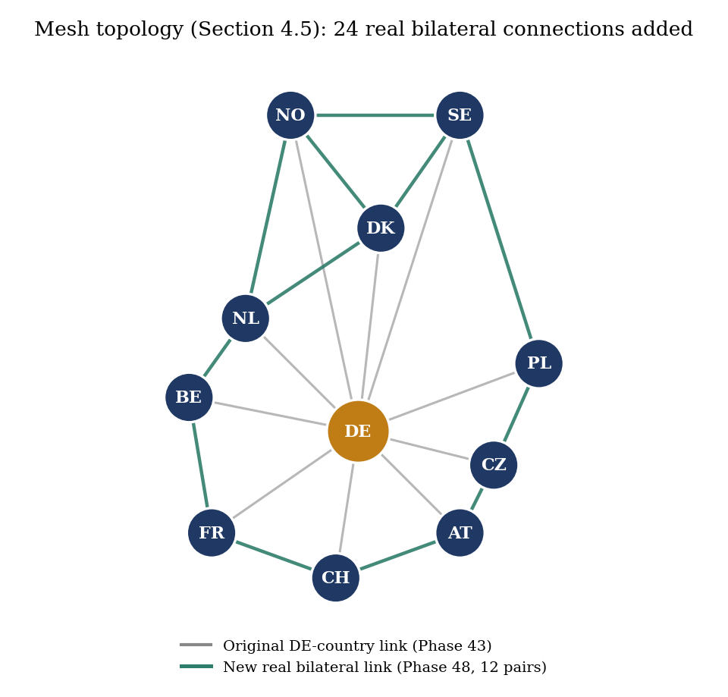
Figure 4.2: The mesh topology: the 24 new real bilateral connections (teal) added on top of the original star topology's Germany-to-country links (grey), covering exactly the 12 real country pairs listed above.

These 24 real connections were added to the Section 4.3 ten-zone build, with every other input, including all of that build's original Germany-to-country transmission values, demand, capacity, renewable, and storage figures, left completely unchanged, so that topology is the only variable isolated by this comparison.
Table 4.4: Aggregate, star, and mesh topology compared, isolating topology as the only variable.
Metric | Aggregate (baseline) | Star topology (Section 4.3) | Mesh topology (new)
Mean price | 67.45 | 112.32 | 105.27
Shortage hours | 7 | 120 | 95
Excl-shortage correlation | 0.7168 | 0.7311 | 0.7297
Excl-shortage bias | -2.90 | +4.87 | +6.05
Excl-shortage MAE | 16.69 | 20.97 | 20.32

The result directionally confirms the star-topology diagnosis from Section 4.4: adding real mesh connections reduced shortage hours by 21 per cent (120 to 95) and moved the mean price measurably closer to Brainpool's real 68.04 EUR/MWh figure (112.32 to 105.27), genuine evidence that the star topology was a real part of the problem rather than a false lead. The metrics that matter most for this project's own trusted comparison, however, did not improve: excl-shortage correlation stayed essentially flat (0.7311 to 0.7297) and bias moved slightly further from zero (+4.87 to +6.05). The aggregate build from Section 3.3.2 remained the strongest result on every trusted metric by a clear margin. Taken together, the full disaggregation investigation across Sections 4.2 to 4.5 establishes a genuine, if somewhat counterintuitive, finding for this thesis: adding more granular, individually real country data does not, on its own, improve this particular comparison, and the simpler aggregate treatment of Rest-of-Europe remains the more defensible choice for the purposes this thesis was set up to serve. This finding, and what it implies about AMIRIS more generally, is developed further in Chapter 6.
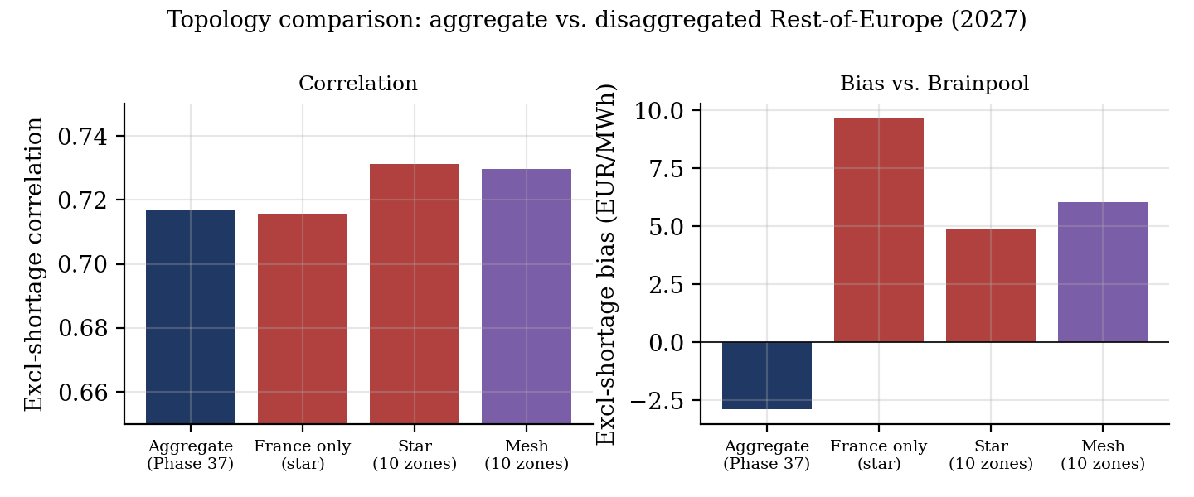
Figure 4.3: Excl-shortage correlation and bias vs. Brainpool across the four topology variants tested in this chapter, computed directly from each build's own result data.

